1. Copy and paste all file to local directly
2. Add the code below the Grips section

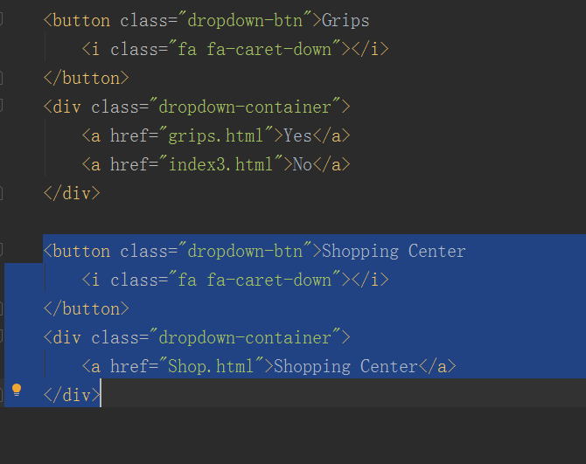

Cart.html and Shop.html contain four JS libraries.

Cookie.js

server.js

index.js

cart.js

Those libraries are used to operation function to store and pass data in shop.html and cart.html. Data will be kept in cookies that will be deleted even users close browsers.